2005 Global Educational Workshop for

Korean Secondary School Teachers of Physics
(KSSTP)
Revised Proposal

프로그램 개발및 진행: 미시간주립대학교 국제 전문인 프로그램

연수 진행진: Andy Anderson (미시간주립대 과학교육학과 교수)
Michael Miller (국제 전문인 프로그램 소장)
주충은 (국제 전문인 프로그램 부소장)
신나리 (국제 전문인 프로그램 연수 코디네이터)

주소: Visiting International Professional Program
1 International Center
Michigan State University
East Lansing, MI 48824-1035

전화번호: 1-517-432-3663~4

팩스: 1-517-353-3010

홈페이지: www.isp.msu.edu/vipp

이메일: vipp@msu.edu

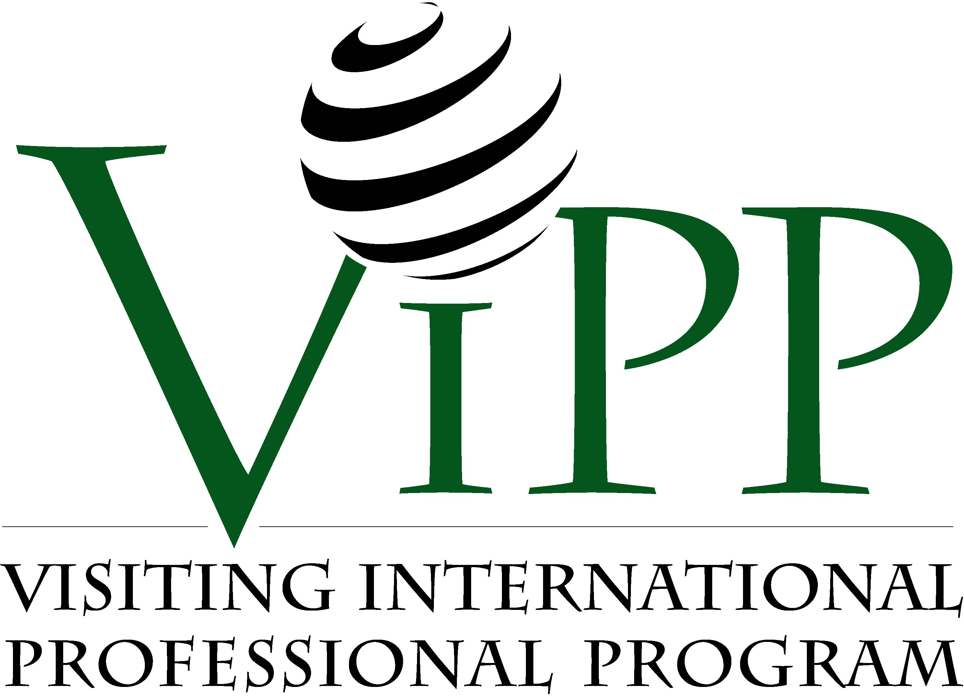

본 제안서는 지난 4월 7일부터 9일까지 실시되었던 국제교육진흥원의 현지 실사시에 논의되었던 내용을 반영한 것으로서, 지난 2월에 미시간 주립대 국제 전문인 프로그램 (이하 VIPP)에서 제출하였던 제안서(예산, 일정 및 강의 계획안)의 수정 내용은 다음과 같다.

I. 일정

- 기숙사 이외의 숙박을 요구하는 장거리 현장 견학은 시카고 관광으로 제한되었다. 이에 나이아가라 관광은 일정에서 제외되었다.
- 시카고 일정은 연수 일정의 가장 마지막 2박 3일로 계획되었다.
- 기존에 13회로 계획되었던 강의는 3회가 추가되어서 총 16회로 변경되었다. 이 중 John Brender의 강의는 특강 형태로 전환되어 총 15회의 전공 강의 및 2회의 특강이 수정된 일정에 포함되었다.
- 강사들의 스케줄에 따라서 8월 21일에 연수를 시작하는 제1안과 8월 14일에 시작하는 제2안 중 제 1안으로 결정되었다.
- 이상의 사항을 반영한 새로운 일정은 다음과 같다.

Korean Physics Workshop Tentative Schedule – NIIED – Plan 1

Monday |  | Tuesday |  | Wednesday |  | Thursday |  | Friday |  | Saturday
 |  |  |  |  |  | 21  (AM)  (PM) | • Arrival | 22  (AM)  (PM) | • Orientation  • MSU campus tour & Registration  • Internet service | 23  (AM)  (PM) | • Welcoming reception (BBQ)
25  (AM)  (PM) | • Lecture 1 (Andy Anderson & Shinho Jang)  • Special lecture (NSCL & PAN) | 26  (AM)  (PM) | • Special meeting (School administrators)  • Professional field research (NSCL) | 27  (AM)  (PM) | • Lecture 2 (Andy Anderson)  • Lecture 3 (Andy Anderson) | 28  (AM)  (PM) | • Lecture 4 (Andy Anderson)  • Professional field research (PAN) | 29  (AM)  (PM) | • Lecture 5 (Andy Anderson)  • Brownbag lunch Seminar (MST)  • Professional field research (Science Theater) | 30  (AM)  (PM) | • Cultural experience
1  (AM)  (PM) | • Lecture 6 (David Fortus)  • Lecture 7 (David Fortus) | 2  (AM)  (PM) | • Professional field research (MST)  • Cultural field research (Capitol tour) | 3  (AM)  (PM)  (EV) | • Lecture 8 (David Fortus)  • Lecture 9 (David Fortus)  • Professional field research (MSU observatory) | 4  (AM)  (PM) | • Lecture 10 (David Fortus)  • Lecture 11 (David Fortus) | 5  (AM)  (PM) | • Lecture 2 (Andy Anderson)  • Professional field research 4 (Local School 1 | 6  (AM)  (PM) | • Cultural experience
8  (AM)  (PM) | • Lecture 13 (Heejun Lim)  • Professional field research (Local School 2) | 9  (AM)  (PM) | • Lecture 14 (Lee Cogan)  • Special Lecture (John Brender) | 10  (AM)  (PM) | • Professional field research (Henry Ford museum)  • Cultural field research (Detroit tour) | 11  (AM)  (PM) | • Lecture 15 (Shinho Jang)  • Professional field research (Kalamazoo Museum Valley) | 12  (AM)  (PM) | • Professional field research (Impression 5)  • Exit review  • Graduation ceremony | 13  (AM)  (PM) | • Cultural experience
15  (AM)  (PM) | • Cultural field research (Chicago) | 16  (AM)  (PM) | • Professional field research  (Field museum)  • Cultural field research (Chicago) | 17  (AM) | • Departure
- NSCL-National Superconducting Cyclotron Laboratory; PAN-Physics of Atomic Nuclei, MST-Math, Science, and Technology Summer Program.
II. 예산

- 3회의 전공 강의 추가로 인해 강사료가 상향조정 되었다.
- 2박의 시카고 일정이 추가되었다. 결과적으로 숙박의 경우 기숙사에서의 2박이 예산에서 제외되는 반면 외부에서 하루 더 늘어났다. 교통비의 경우 랜싱-시카고간의 버스가 아닌 시카고 시내교통만을 위한 버스 대절로 감소된 반면, 통역 및 스텝 총 2인의 랜싱-시카고간 비행료가 추가 책정되었다.
- 강의 및 시카고 일정의 추가로 인해 기존에 계획되었던 나이아가라 일정이 수정된 일정에서 제외되었다. 이에 나이아가라 일정에 책정되었던 교통비, 인건비 및 숙박료 등이 제외되어 예산에 반영되었다.
- 통역의 경우 국제교육진흥원 및 과학교육학과 교수진의 요청에 따라 과학교육학 전공자로 대치됨으로써 이에 대한 예산이 상향 조정되었다.
- DS2019 processing fee (100불)은 본 예산안에 반영되지 않았으며, 연수 참여자들의 입국 비자 유형을 J1 비자로 결정하는 경우, 연수 참여자들이 VIPP에 온라인으로 입학허가 신청을 할 때 필요한 신청료(application fee)로 대체하도록 하며, 각 연수 참여자들이 개별적으로 온라인 신청과 함께 VIPP에 지불하는 것으로 한다. 이같은 입국 비자 유형의 최종 결정은 국제교육진흥원에서 하도록 한다.
- 주말 저녁 식대 현금 지급안의 경우, 이에 해당하는 금액은 각 참여자들에게 자유식으로 예정된 주말 저녁 식대 8회에 해당하는 금액 100불이다. 현급 지급에 있어서 미시간 주립대에서 행정적으로 가능한 방법으로 제시된 방법은 다음의 두가지이다. 첫번째, 각 참여자에게 주말 식대에 해당하는 개인 수표 지급이 가능하다. 이경우 행정 절차로 인해 연수 후반기에 지불이 가능하며, 현금이 아닌 관계로 미국 현지에 은행 구좌가 없는 경우 현금화하는 것이 불투명하다. 두번째 방법은 실제 현급 지급으로서, 이경우 각 연수 참여자가 일련의 해당 서류를 학교 당국에 작성하여 제출하여야 하며, 현금 지급을 위해 각 개인별로 15불의 수수료를 학교에 지불하여야 하므로 실제적으로 개인에게 지급되는 현금은 85불이다.
위의 두가지 방법이 실제적으로 현실적거나 합리적이지 않다고 판단되는 경우, 현금은 지급하지 않는 대신 기존에 계획된 일정에 개인당 100불에 해당하는 식사 또는 일정을 추가 계획하도록 한다. 이에 해당하는 것으로는 디트로이트 관광 이후 식사 및 야구 관람, 시카고 관광시 페리 등의 특별 관광, 로컬 식당에서의 주말 식사 등이 있으며, 연수 이전기간 혹은 오리엔테이션 기간 중에 연수 참여자들과 합의하여 결정하도록 한다.
- 이상의 사항을 반영한 새로운 예산안은 다음과 같다.
예 산 안

Tuition Costs: $8,750
- Compensation for Instructors: $7,100
Instructors of regular sessions (including lab), special lectures and meetings
- Education Materials: $1,650
Folders, copies, lecture materials

Administrative Costs: $55,084
- Salaries for Administrators and Staff: $27,920
Pretime for executive staff, pretime for project coordinator, project coordinator
- Translators: $3,120
- Direct Expenses: $1,040
Postage, Copies, Supplies, etc.
- Ground Transportation for Field Trip: $1,800
Bus for airport rides, Vans for local field visits
- Assistants for Field Trips: $1,200
- Other Direct Costs: $20,004
Central administration overhead charge, VIPP coordination fee, contingency

Individual Maintenance Cost: $30,215
- Lodging in Academic Residency: $10,300
Double bedroom for 27 days
- Meals in Academic Residency: $6,845
Breakfast, lunch, dinner, BBQ, welcome reception, farewell party
- Lodging in Site Visit: $3,450
Niagara and Chicago
- Meals for Site Visit: $1,380
Lunch, dinner
- Weekend dinner cost: $2,100
- Travels to Site Residency: $5,460
Transportation, meals, lodging for staff and drivers
- Professional/Cultural Site Admission: $680
Museums, etc.

Total cost: $94,049
Cost per capita: $4,479
VIPP scholarship: $8,000
NIIED final cost: $86,049

III. 강의 계획안

- 기존에 계획된 과학교육학과 교수들의12회 전공 강의 이외에 평가를 주제로 한 강의를 3회 추가하였다. 이로써 총 15회의 전공 강의가 계획되었다.
- 기존 연수 계획안에 계획되었던 각 전공 강의의 내용은 기존의 물리 교수 학습 중심의 강의내용과 더불어 평가의 내용을 포함하도록 한다.
- 추가된 강의 시간에 해당하는 전공 현장 견학 (Professional field research)은 원 계획에서 제외되었다.
- 새롭게 계획된 강의 계획 및 해당 강사는 다음과 같다.

Lecture 1. Schooling in the United States and Korea (Andy Anderson and Shinho Jang)
The lecturers will compare their experiences working in the United States and Korea, discussing similarities and differences in the two countries. The discussion will include:
- General organization of the school systems
- Similarities and differences in students, classroom climates, and students’ ideas about the purposes of schooling
- Teaching strategies and styles
- Teacher education and teachers’ career paths

Lecture 2. Principles of Instruction (Andy Anderson)
The session will be built around a demonstration with follow up discussion concerning conservation of mass and forces on objects. The discussion will be used to present and explain three key principles of instruction that will be modeled and practiced in future sessions:
I. Nature of scientific reasoning
A. Understanding as connected experiences, patterns, and explanations
B. Importance of qualitative reasoning as a basis for quantitative reasoning
C. Rigor as consistent, detailed use of simple models
II. Importance of student reasoning
A. Specific misconceptions (for example, that we see out from our eyes)
B. Sense-making strategies
- Procedural display: Following procedures that are personally meaningless to get correct answers
- Narrative reasoning: Learning stories and steps in procedures
- Practical reasoning: Finding and using patterns
- Model-based reasoning: Connecting experiences, patterns, and models
C. Qualitative models as essential bridges between student reasoning and scientific reasoning
D. Assessment and dialogue as key strategies for engaging students’ personal reasoning
III. Learning Cycles as a Way to Help Students Learn Difficult Content
A. Transfer of responsibility
B. Prerequisites for a learning cycle
- An objective focusing on inquiry or application
- Sets of examples (experiences), patterns, and explanations
- Clearly defined patterns in student practice (scaffolding for modeling and coaching)
C. Specific steps in learning cycles

Lecture 3. Purposes and Principles of Assessment (Andy Anderson)
The session will build on the previous demonstration and discussion to discuss purposes of classroom assessment, introduce principles for designing assessments for different purposes, and begin practice in developing assessment items on this topic.
I. Purposes of Classroom Assessment
Purpose | Essential Qualities | Ways to Be Efficient
Grading | - Connection to goals  - Appropriate difficulty (reasonable risk)  - Transparency (e.g., clear rubrics) and reliability (consistent scores for same student) | Avoid too many essays
Helping students assess their own understanding | - Connection to goals  - Promoting student thinking about big ideas  - Quick personal feedback | Students checking their own or each other's work
Improving instruction | - Connection to goals  - Exploring the nature and limits of students' understanding, not just how well they did  - Providing opportunities for interesting wrong answers that reveal students' thinking | Sample students with clinical interviews or complex questions
II. Issues to consider as you develop assessment tasks
- The research literature can be a valuable source for ideas about tasks and about likely misconceptions.
- The best tasks are often ones that a scientist would answer with the patterns and theories you intend to teach. If you are going to be teaching about heat transfer, for example, try to think of questions that scientists would answer with ideas about heat transfer—if heat transfer is the answer, then what is the question?
- It is often more useful to ask about specific examples than to try to get students to explain their models and theories.
III. Examples of Classroom Assessments
1. Clinical interviews looking in depth at reasoning of individual students
2. Questions for specific topics (focus on topics taught earlier)

Lecture 4. Topic-specific Teaching: Force and Motion (Andy Anderson)
This session will be modeled on Jim Minstrell’s teaching of force and motion, using a combination of in-class assessments, demonstrations, and videos of Minstrell teaching. Teachers will discuss the application of the instructional principles introduced in Lecture 2 to this topic.

Lecture 5. Topic-specific Assessment: Force and Motion (Andy Anderson)
In this session teachers will apply the principles of classroom assessment discussed in Lecture 3 to evaluate and develop items to assess students’ understanding of force and motion. In addition to developing and evaluating their own items, teachers will investigate and discuss items developed and available as resources, particularly from Jim Minstrell and Eric Mazur.

Lecture 6. State and National Assessments: NAEP and MEAP (Andy Anderson)
The lecturer will discuss his experiences on the planning committees and development teams for the Michigan Educational Assessment Program (MEAP) and the National Assessment of Educational Progress (NAEP). The primary emphasis will be on NAEP, where the development process is currently under way.
1. My experiences in developing framework
2. Key components of framework
- Content: Experiences, patterns, explanations
- Practices: Application and inquiry
- Learning progressions that connect content and practices across grade levels
3. Process of developing NAEP Assessment
- Framework
- Item specifications: Crossing content and practices, adding experiences
- Development of specific tasks or items

7. Topic-specific Teaching: Energy Conservation (David Fortus)
This lesson will be modeled on a lesson developed as part of the NSF-funded PBI project. Students will engage in two different experiments demonstrating that energy is apparently not conserved. Teachers will discuss the application of the instructional principles introduced in Lecture 2 to this topic.

8. Topic-specific Assessment: Energy Conservation (David Fortus)
In this session teachers will apply the principles of classroom assessment discussed in Lecture 3 to evaluate and develop items to assess students’ understanding of energy conservation. In addition to developing and evaluating their own items, teachers will investigate and discuss items developed and available as resources.

9. Topic-specific Teaching: Structural Integrity (David Fortus)
This lesson will demonstrate the value of jigsawing activities and results. Teachers will investigate the relationship between a beam’s deflection and: a) the weight it supports, b) its cross-section, and c) the distance between the beams supporting it. Teachers will discuss the application of the instructional principles introduced in Lecture 2 to this topic.

10. Topic-specific Assessment: Structural Integrity (David Fortus)
In this session teachers will apply the principles of classroom assessment discussed in Lecture 3 to evaluate and develop items to assess students’ understanding of structural integrity.

11. Topic-specific Teaching: PSOEs (David Fortus)
This lesson will demonstrate and elaborate the principles of designing and using PSOEs (Predict, Share, Observe, Explain) as mean of engaging and assessing student understanding. Teachers will discuss the application of the instructional principles introduced in Lecture 2 to this topic.

12. Topic-specific Assessment: Light (David Fortus)
This lesson is based on a lesson developed as part of the NSF-funded IQWST project. Teachers will investigate how to use MBLs (Microprocessor-Based Laboratories) in learning about light, measurement, and data analysis. In this session teachers will also apply the principles of classroom assessment discussed in Lecture 3 to evaluate and develop items to assess students’ understanding of light and the process of measurement.

Lecture 13. American and Korean Science/Physics Textbooks (Heejun Lim)
This session will examine the science textbook adoption practice in U.S., which plays an important role to determine the content and quality of science, in particular physics, textbooks. The different science textbooks in U.S. will be investigated and compared. Teachers will have a chance to evaluate the textbooks in order to make a choice of the quality resources for their own teaching practice, while presenting their evaluation criteria. They will be then introduced to the current curriculum analysis processes in U.S. For example, Project 2061 curriculum analysis framework and Lansing School District framework will be discussed. Finally, the session will discuss the different textbook adoption criteria and processes between Korean and U.S. science and physics textbooks.

Lecture 14. TIMSS and International Assessments (Lee Cogan)
The session expands on previous sessions addressing the goals and purposes of classroom assessment, reviewing the linkages between assessment goals and purposes and instrument validity and reliability. The main focus of this session is to introduce assessment as it may be used in program (curricular) evaluation and, more specifically, how this goal is accomplished through an international comparative study. Topics discussed will include:
- The utility of assessment types, e.g., multiple choice, constructed response, for various educational evaluation goals, e.g., classroom instruction or program evaluation.
- Balancing breadth and depth of evaluation with the assessment goal.
- The creation of a multidimensional curricular portrait by employing multiple measures at various levels: the intended, implemented, and attained curriculum.
- The rationale for international comparative assessments such as TIMSS.

Lecture 15. National Science Education Standards and Concluding Discussion (Shinho Jang)
The purpose of this session is to understand overarching assessment goals of school science. In this session teachers will have chances to look at an overview of Assessment standards recommended by National Academy of Sciences through National Science Education Standards. The general goal and specific strategies for assessment will be a focus content in this session. Based on the suggestions in the National documents, the teachers will have in-depth discussions to think about ways to successfully achieve the effective assessment performance in their classroom teaching physics. The detailed topics are:
- Components of the assessment process in classroom teaching physics
- Assessment standards
- Assessments conducted at the national, state, district levels
- Practice to implement assessments by physics teachers in classroom

