International Journal of Science Education
Part B Communication & Public Engagement (2011~2012 present)
2011  Volume 1  Issue 1 | 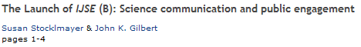
 | 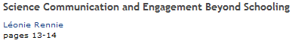
 | 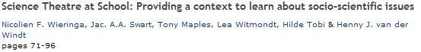
2011  Volume1  Issue 2 | 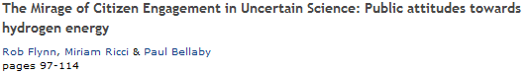
2012
Volume 2
Issue 1
 | 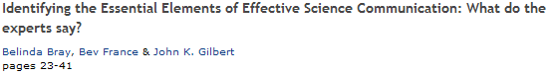
 | 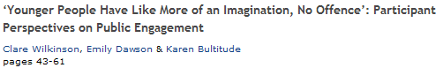
 | 